Урок английского языка
Тема «An ideal society. Sir Tomas More’s “Utopia”».

9 класс.
Учитель: Коробов А.В.
Aims:
1) Analyze the text and find the features of the ideal society.
2) Form your own attitude to the problem.
3) Practice new vocabulary.
Ход урока:
Good morning. I think you are ready. Let’s start our lesson. What do you think we are speaking about? Yes, as you have guessed, today we’ll speak about an ideal society.
1.There are 4 quotations what do you think about them.
«Governments exist to protect the rights of minorities. The loved and the rich need no protection: they have many friends and few enemies».
/Wendell Phillips/
«There is no such thing as Society.
There are individual man and woman,
And there are families».
/Margaret Thatcher/

«No one pretends that democracy is perfect or all-wise.
Indeed, it has been said that democracy is the worst form of government except all those other forms that have been tried from time to time».
/Winston Churchill/

«Democracy… is a charming form of government, full of variety and disorder, and dispensing a sort of equality to equals and unequals alike».
/Plato/

2. Work with the text p.70 ex.9,p.71 ex.10.

3. Lets discuss basic terms, questions.

Basic terms:
- Elective system
- Democracy
- Civil freedoms and rights
- Public property
- Classless society
- Equality
- Xenophobia
- Tolerance
- International cooperation
- Euthanasia

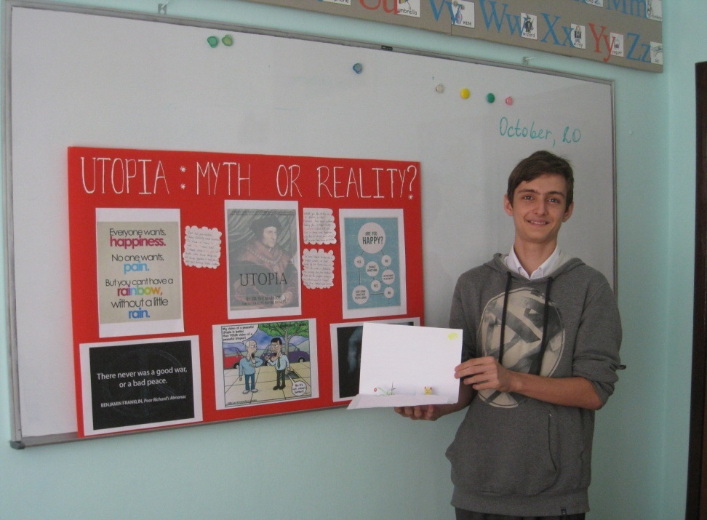
Qestions:
- 1. What will happen to the society where an individual doesn’t matter, where people are oppressed? What dictatorial regimes do you know? What do they have in common?
- 2. What genre will appear if the book depicts inhuman society? What did you read?
- 3. Why don’t we have utopia as a genre of books nowadays?

4. Reflexion
- An Ideal society
- Fair and humanistic
- Work, share, respect.
- The distant aim of the humanity.
- Utopia…

Homework: write a letter about ideal society.

